**EEG Classification Project Report**

**Project Overview**

This project focuses on classifying EEG signals using two distinct approaches:

* **Logistic Regression** with log-variance features
* **EEGNet**, a compact deep learning architecture tailored for EEG data

The goal is to evaluate and compare their performance across multiple cross-validation folds.

**Dataset & Preprocessing**

* **Input shape**: EEG epochs of shape (N, C, T)
  + N: number of samples
  + C: number of channels
  + T: number of time points
* **Preprocessing**:
  + Band-pass filtering
  + Epoch extraction
  + Feature extraction (log-variance for Logistic Regression)

**⚙️ Models**

**1. Logistic Regression**

* Features: Log-variance across channels
* Optimizer: Momentum-based gradient descent
* Regularization: L2 penalty
* Hyperparameters:
  + Epochs: 1000
  + Learning rate: 0.01
  + Batch size: 8
  + L2: 1e-5

**2. EEGNet**

* Architecture: Depthwise and separable convolutions
* Input: Raw EEG epochs
* Optimizer: Adam
* Loss: CrossEntropy with label smoothing
* Hyperparameters:
  + Epochs: 100
  + Learning rate: 5e-4
  + Batch size: 32
  + Dropout: 0.0
  + Early stopping: Patience = 20

**Results**

**Logistic Regression**

* **Mean Accuracy**: 0.6076 ± 0.0299
* **Accuracy per Fold**:  
  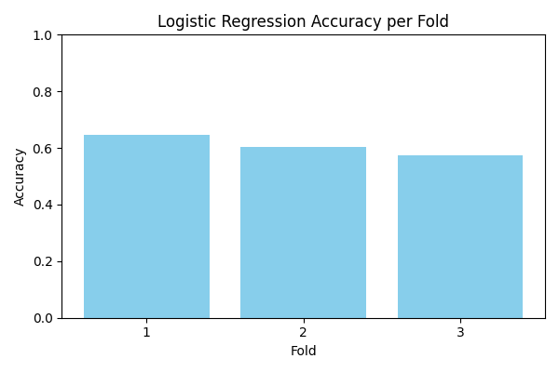
* **Confusion Matrices**:  
  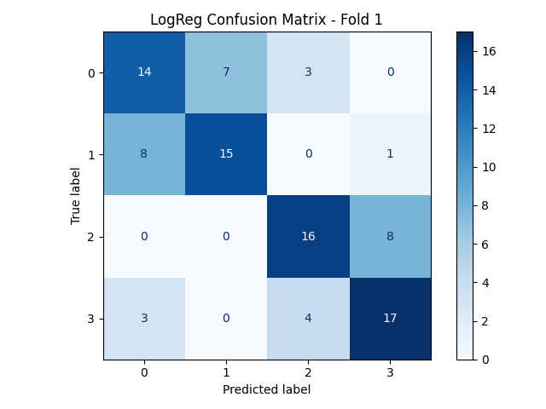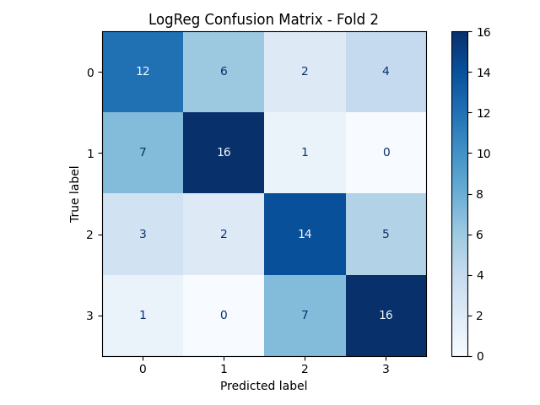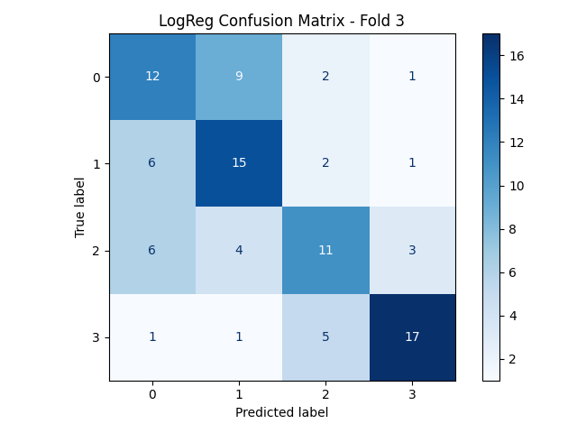

**EEGNet**

* **Mean Accuracy**: 0.5833 ± 0.0225
* **Accuracy per Fold**:  
  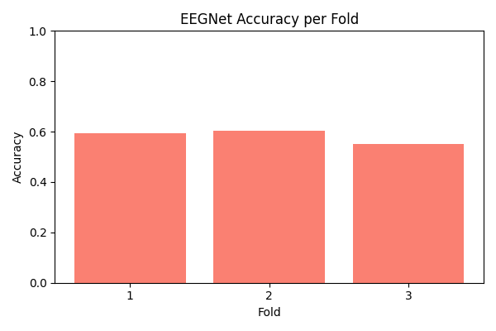
* **Confusion Matrices**:  
  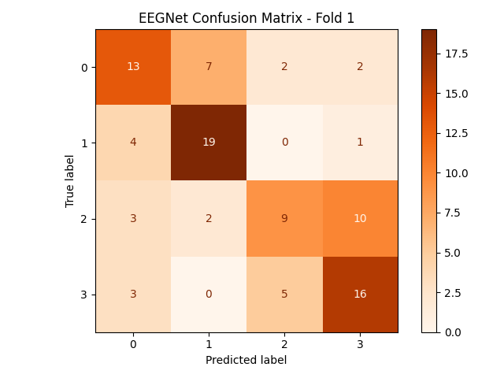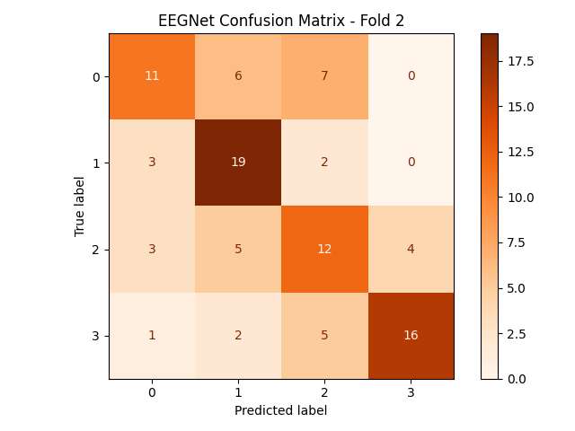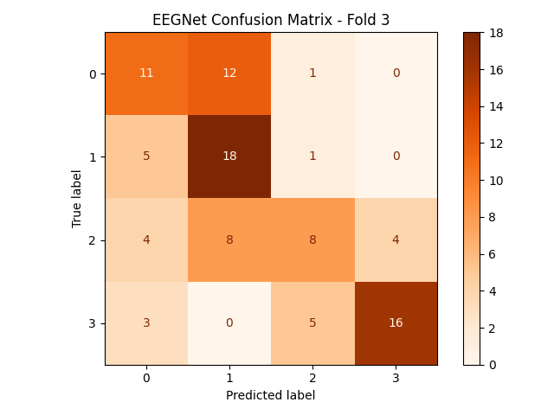

**Comparison & Insights**

| **Model** | **Mean Accuracy** | **Training Time** |
| --- | --- | --- |
| Logistic Regression | 0.6076 ± 0.0299 | Fast |
| EEGNet | 0.5833 ± 0.0225 | Longer |

* Logistic Regression is lightweight and interpretable.
* EEGNet captures temporal and spatial patterns more effectively.